TRƯỜNG ĐẠI HỌC CÔNG NGHỆ THÔNG TIN VÀ

TRUYỀN THÔNG VIỆT – HÀN
KHOA KỸ THUẬT MÁY TÍNH VÀ ĐIỆN TỬ


HỆ ĐIỀU HÀNH NHÚNG

HỆ THỐNG PHÁT HIỆN VA CHẠM

Sinh viên thực hiện: | NGUYỄN VĂN AN – 21CE002
Giảng viên hướng dẫn: | TS. VƯƠNG CÔNG ĐẠT

Đà Nẵng, tháng 05 năm 2026

TRƯỜNG ĐẠI HỌC CÔNG NGHỆ THÔNG TIN VÀ
TRUYỀN THÔNG VIỆT – HÀN
KHOA KỸ THUẬT MÁY TÍNH VÀ ĐIỆN TỬ


HỆ ĐIỀU HÀNH NHÚNG
HỆ THỐNG PHÁT HIỆN VA CHẠM

Sinh viên thực hiện: | NGUYỄN VĂN AN – 21CE002
Giảng viên hướng dẫn: | TS. VƯƠNG CÔNG ĐẠT

Đà Nẵng, tháng 05 năm 2026

THANK YOU
To successfully complete this project, I received invaluable assistance and guidance from the lecturers of the Department of Computer and Electronic Engineering – Vietnam-Korea University of Information and Communication Technology. I would like to thank the lecturers in the specialized department for providing us with extremely valuable and necessary information and knowledge throughout the process, enabling me to complete my report. In particular, I would like to sincerely thank Mr. Vuong Cong Dat – my supervising lecturer – for imparting useful knowledge during the process of completing our Embedded Systems project.
Finally, I would like to express my sincere gratitude to my colleagues in the field for their support, assistance, and sharing of knowledge, experience, and materials that helped me in the research and completion of this thesis. Due to limitations in time, knowledge, and practical experience, the thesis inevitably contains some errors. I sincerely hope for the understanding of my professors and look forward to receiving feedback from my professors and peers.
Thank you very much!

COMMENT
(From the supervising lecturer)
……………………………………………………………………………………………………………………………………………………………………………………………………………………………………………………………………………………………………………………………………………………………………………………………………………………………………………………………………………………………………………………………………………………………………………………………………………………………………………………………….

Da Nang, [date] [month] 2025
Instructor
Dr. Vuong Cong Dat

CONTENTS
THANK YOU i
COMMENT ii
IMAGE LIST iv
INTRODUCE 1
CHAPTER 1 INTRODUCTION AND APPLICATIONS OF THE SYSTEM 3
1.1 Project context 3
1.2 Practical applications 3
1.3 Project objectives 4
CHAPTER 2 HARDWARE DESIGN 5
2.1 Central microcontroller – ESP32 (DEVKIT ESP32 V1) 5
2.1.1 Key physical characteristics: 5
2.1.2 Integrated peripherals: 5
2.2 Distance sensor – VL53L0X (Time-of-Flight) 6
2.3 3-axis accelerometer sensor – ADXL345 (MEMS) 6
2.4 1.3-inch OLED screen (SH1106) 7
2.5 LED arrays and pulse width modulation (PWM) principles 8
2.6 I2C communication standard – Shared bus structure and physics issues 8
2.7 Overall power supply and connection diagram 9
2.8 Chapter Summary 10
CHAPTER 3 DEPLOYMENT AND CODING WITH FREERTOS 11
3.1 Overall algorithm flowchart of the system 11
3.2 Program structure and source code analysis 11
3.2.1 Declare libraries and configure hardware. 11
3.2.2 Data Structures of the Sensor Data 12
3.2.3 Task 1 – Read the sensor (TaskDocCamBien) 12
3.2.4 Task 2 – OLED Display (TaskHienThiOLED) 13
3.2.5 Task 3 – LED Control (TaskDieuKhienLED) 14
3.2.6 Task 4 – Watchdog Monitoring (TaskGiamSat) 14
3.3 The FreeRTOS mechanism is unique to this system. 14
3.3.1 Core affinity 14
3.3.2 Mutex – protecting shared resources 15
3.3.3 Queue – for passing information between tasks 15
3.3.4 Time and watchdog synchronization 15
3.3.5 Stack and heap management 16
3.3.6 Latency and real-time response 16
3.4 Conclusion of Chapter 3: 16
CONCLUDE 17
REFERENCES 18

IMAGE LIST
Figure 1 -1 ESP in practice 3
Figure 1 -2 Using VScode and platform for ESP32 4
Figure 2 -1 ESP32 6
Figure 2 -2 VL53L0X 7
Figure 2 -3 ADXL345 7
Figure 2 -4 OLED 8
Figure 3 -1 Flowchart 12


INTRODUCE
1. Background and Significance of the Project
In recent years, the Internet of Things (IoT) and Embedded Systems have been developing rapidly, especially in safety applications such as collision warning systems for cars, robots, or assistive devices for the visually impaired. However, traditional single-loop programming architectures often struggle to handle multiple tasks simultaneously, leading to high latency and instability when reading data from multiple sensors. To address this problem, Real-Time Operating Systems (RTOS) combined with powerful multi-core microcontrollers like the ESP32 have become the industry standard. FreeRTOS allows for optimal allocation of system resources, ensuring that critical tasks are prioritized for immediate processing. This project focuses on designing and implementing a multi-tasking Collision Warning System, leveraging the power of ESP32 hardware and I2C sensors to deliver instantaneous response and high reliability.
2. Project Objectives
The main objectives of the project include:
- Gain a deep understanding and practical application of multitasking architecture on the FreeRTOS operating system using both cores (Core 0 and Core 1) of the ESP32 microcontroller.
- Design a system for parallel data acquisition from a laser proximity sensor (VL53L0X) and an accelerometer sensor (ADXL345) without causing transmission conflicts.
- Master and implement Inter-Process Communication (IPC) mechanisms in industry, including Queues and Mutexes.
- Optimize real-time display capabilities on OLED screens using a Dirty-check algorithm instead of refreshing the entire screen.
- Deliver a complete, smoothly functioning system with a watchdog mechanism to detect and alert you to memory overflow errors or task hangs.
3. Scope of the Project
This project will focus on the following areas:
- Hardware implementation: Integration of ESP32 with SH1106 OLED display (1.3 inch), VL53L0X ToF sensor, ADXL345 accelerometer, and LED warning system via I2C communication (overclocked to 400kHz).
- Multitasking software design: Building 4 independent tasks including: Sensor data collection (Priority 3), OLED display (Priority 2), PWM LED control (Priority 1), and System monitoring (Priority 3).
- Synchronization Handling: Use Mutex to protect shared I2C communication channels and use Queue (1-slot Overwrite mode) to transmit the latest data stream without causing memory bottlenecks.
- The project at this stage does not include data transmission via WiFi/MQTT or storing activity history on an SD card.
4. Implementation Method
The project was implemented in four clearly defined phases:
- Phase 1: Hardware Specification & Selection – System requirements analysis, component selection, I2C address determination, and overall block diagram design.
- Phase 2: Firmware Design – Programming distributed modules using C++ (Arduino Framework) on PlatformIO. Building data structures, configuring tasks, queues, and mutexes.
- Phase 3: System Optimization – Applying Dirty-check techniques to OLEDs, overclocking I2C, fine-tuning sensor sampling times, and configuring priority levels to achieve the lowest possible system latency.
- Phase 4: Simulation, Testing & Reporting – Run system experiments, analyze RAM consumption via Watchdog Task, evaluate stability, and finalize the technical report.
5. Report Structure
Chapter 1 – Introduction and Applications of the System
Chapter 2 – Hardware Architecture and Communication
Chapter 3 – Deploying Code and the FreeRTOS Operating System
Documents


INTRODUCTION AND APPLICATIONS OF THE SYSTEM

Project context
In the era of the Internet of Things (IoT) and automation, safety is paramount. Systems, from industrial robots to consumer appliances, require the ability to perceive their surroundings to avoid collisions. However, traditional warning systems often operate on a single-loop architecture. The limitation of this architecture is that when the system has to process multiple sensors simultaneously or perform heavy tasks (such as drawing graphics on a screen), it generates significant latency. In dangerous situations requiring millisecond-level reflexes, this delay can lead to serious consequences.
To address the above problem, this project proposes a solution using a Real-Time Operating System (RTOS) combined with a multi-core microcontroller. By dividing the workload into parallel tasks, the system can ensure that data collection and alerting are always continuous, real-time, and free from bottlenecks.
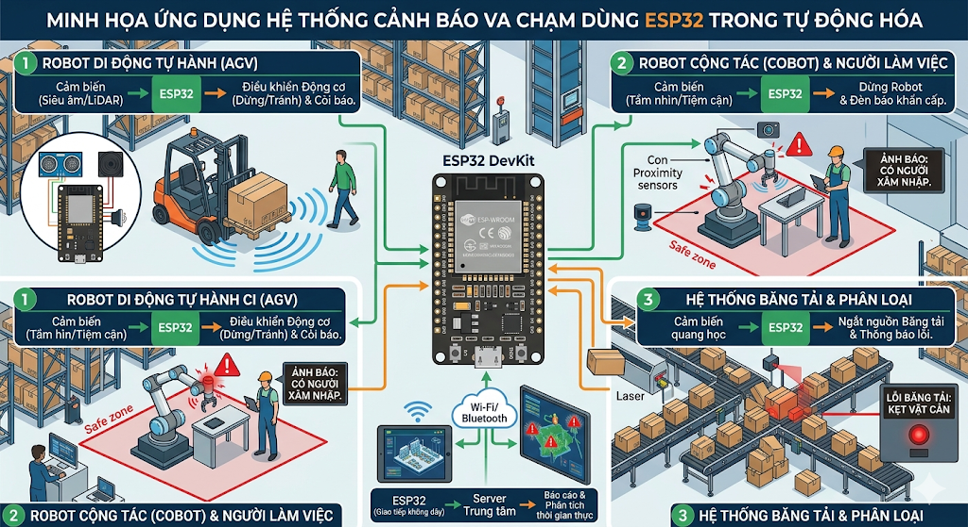
Figure 1 -1 ESP in practice

Practical applications
With its compact design and real-time response capabilities, the collision warning system developed in this project can be easily customized and integrated into various aspects of life:
- Autonomous Vehicles (AGVs) & Drones: Integrated as "eyes" to help robots automatically stop or change direction when they detect sudden obstacles or when traveling over bumpy terrain.
- Traffic safety support: Applications include blind spot warning systems or reversing assistance systems, providing audible signals and flashing LED lights when the vehicle gets too close to an obstacle.
- Medical devices/Assistant tools for people with disabilities: Integrated into "smart canes" for the visually impaired, helping to detect obstacles in front and warn of danger through vibration or sound feedback.

Project objectives
The project aims to research, design, and build a prototype of a collision warning system operating on the FreeRTOS operating system. Specific objectives include:
- Hardware development: Assembled a system using an ESP32 microcontroller, a 1.3-inch OLED display (I2C communication), a laser proximity sensor (VL53L0X), a 3-axis accelerometer (ADXL345), and an LED warning light cluster.
- Implementing a professional programming environment: The entire system is programmed on the PlatformIO platform integrated into Visual Studio Code (VS Code), using the Arduino Framework and the C++ language to ensure optimal library management and compilation capabilities.
- Multitasking software design: Utilizing FreeRTOS's Multitasking architecture, CPU threads are used to simultaneously process measurement tasks, display dirt-checks, and pulse width modulation (PWM) to dim warning LEDs.
- Performance monitoring: Built-in Watchdog mechanism to automatically monitor the heart rate of tasks and RAM usage, ensuring the system doesn't freeze during continuous operation.
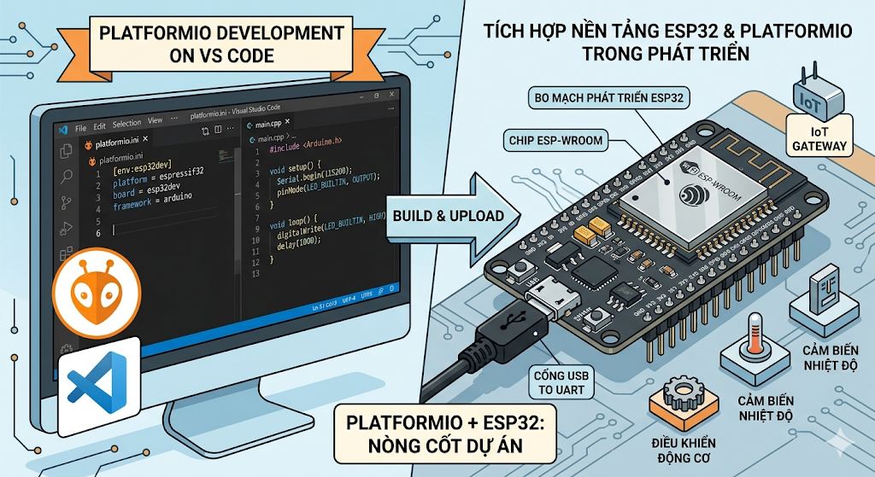
Figure 1 -2 Using VS Code and platform for ESP32

HARDWARE DESIGN
In real-time embedded systems, the selection of hardware components and the method of connecting them are crucial to the performance, stability, and scalability of the product. The collision warning system presented in this project is built on advanced hardware modules, making full use of the I2C communication standard to save GPIO pins, reduce noise, and optimize data transmission speed. This chapter will delve into the analysis of each hardware block, its characteristic technical specifications, and how they are interconnected on the data bus.

Central microcontroller – ESP32 (DEVKIT ESP32 V1)

The brain of the entire system is the ESP32-WROOM-32 module integrated on the DOIT ESP32 DEVKIT V1 board. This is a 32-bit Xtensa LX6 architecture microcontroller, a System on Chip (SoC) manufactured by Espressif.

Key physical characteristics:
- Dual-Core Architecture: The ESP32 features two independent processing cores, designated as Core 0 (Protocol Core) and Core 1 (Application Core). In the system, Core 0 is solely dedicated to reading data from sensors, while Core 1 handles displaying information on the OLED screen and controlling the LEDs. This rigid separation eliminates the need for CPU resource contention, minimizing conflicts with internal bus access.
- Operating frequency: Maximum clock speed reaches 240 MHz. For applications requiring fast response (collision warning within 25ms), the system is typically configured to run at 160 MHz or 240 MHz, ensuring that the data channel processing time does not exceed the sampling cycle.
- SRAM Memory: The 520 KB SRAM is divided into regions: 240 KB dedicated to data (data RAM), 16 KB for the RTC cache, and the remainder for tasks. This allows the system to maintain multiple queues and stacks of FreeRTOS tasks without worrying about memory overflow.

Integrated peripherals:
The ESP32 has built-in I2C, SPI, UART, and PWM (LEDC) control modules – all mapped to GPIO pins via a GPIO matrix switch. Specifically, the system uses:
- I2C controller #0 (SDA = GPIO21, SCL = GPIO22) for simultaneous communication with 3 slave devices.
- The PWM generator (LEDC) on two independent channels controls GPIO18 and GPIO19, allowing LED brightness adjustment with 8-bit resolution (0–255).
- Operating and Protection Voltage: The ESP32 operates at a logic level of 3.3V, therefore all peripheral modules connected via I2C must also be compatible with this voltage level. The GPIO pins already have a weak pull-up resistor (approximately 30kΩ – 50kΩ) that can be activated by software, but to ensure I2C transmission stability, the system still adds a pull-up resistor of 2.2kΩ – 4.7kΩ on both the SDA and SCL lines.

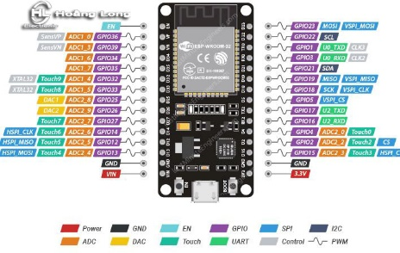
Figure 2 -1 ESP32

Distance sensor – VL53L0X (Time-of-Flight)

Physical principle: Unlike ultrasonic sensors (using sound waves) or simple infrared reflection sensors, the VL53L0X uses Time-of-Flight (ToF) technology based on laser diodes. This module emits a short infrared laser pulse (940 nm wavelength, safe for the human eye) and accurately measures the time it takes for photons reflected from the obstacle to return to the SPAD (Single Photon Avalanche Diode) receiver. From the return time ∆t, the distance is calculated using the formula:
d = (c × ∆t) / 2, where c is the speed of light in air (≈ 3.0×10⁸ m/s).

Technical specifications:
- Measuring range: 30 mm – 1200 mm (maximum up to 2000 mm under ideal conditions, but reliability is reduced). In this system, the "Too Far" threshold is set at 1200 mm to avoid displaying noisy data.
- Accuracy: ±3% at close distances, ±5% at far distances. Systematic error is less than 10 mm when measuring objects with medium reflective surfaces (gray, white).
- Measurement speed: Can reach up to 50 Hz (20 ms/cycle) when configured in “Fast Mode” – this is compatible with the 25 ms sampling cycle required by the system.
- Field of View (FoV): 25° (cone-shaped), which helps focus on obstacles in front and reduces signal from nearby objects.
- I2C communication and addressing: The VL53L0X complies with the I2C standard (speeds up to 400 kHz). The default device address is 0x29 (7 bits). The manufacturer allows changing the address by writing to the I2C_SLAVE_DEVICE_ADDRESS register; however, in this system, since there is only one ToF sensor, the address 0x29 remains unchanged.

Practical application: Thanks to its fast measurement capabilities and unaffected by color or light-absorbing materials (except mirrors or completely black surfaces), the VL53L0X is preferred over ultrasonic sensors (prone to acoustic interference) or Sharp infrared sensors (accuracy decreases with distance).

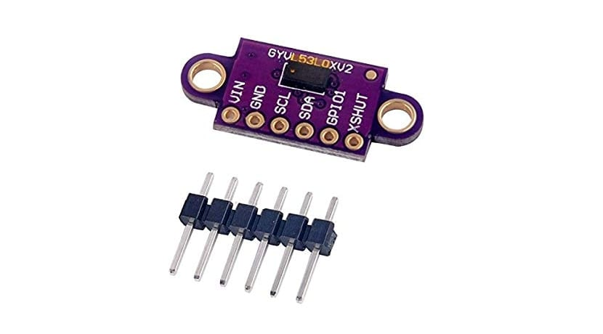
Figure 2 -2 VL53L0X

3-axis accelerometer sensor – ADXL345 (MEMS)

Micro-mechanical structure: The ADXL345 is a micro-electromechanical system (MEMS) built on a silicon chip. Inside, it contains a small mass (proof mass) suspended by micro-springs. When acceleration is applied, this mass moves, changing the capacitance between the plates. An adjacent ASIC (Application-Specific Integrated Circuit) converts this capacitance change into a digital value output via I2C.

Hardware specifications:
- Measurement Range: ±2g, ±4g, ±8g, ±16g can be selected. In this system, the ±4g range is chosen because the alarm threshold of 5.0 m/s² ≈ 0.5g, which falls within the first half of the measurement range, while still being able to detect strong impacts up to 4g.
- Resolution: 10 bits (corresponding to a range of ±4g, resolution ≈ 7.8 mg/LSB). This number is sensitive enough to detect small vibrations but does not cause false interference due to mechanical noise.
- Sampling rate (Data Rate): Can reach 3200 Hz, but the system only needs a rate of 100 Hz (new data every 10 ms). With a sensor readout cycle of 25 ms, accelerometer data is always updated in a timely manner.
- Operating voltage: 2.0V – 3.6V, fully compatible with the 3.3V of the ESP32.
- Default I2C Address: The ADXL345 has two addresses depending on the SDO/ALT pin (Alternate I2C Address). If SDO is grounded (GND), the address is 0x53; if SDO is connected to VCC, the address is 0x1D. In the design, the SDO pin is pulled down to GND, therefore the address is 0x53.

Hardware filter integration: The ADXL345 features a built-in low-pass filter with a configurable coefficient via registers. This helps eliminate high-frequency noise from environmental vibrations, preventing false alarms.

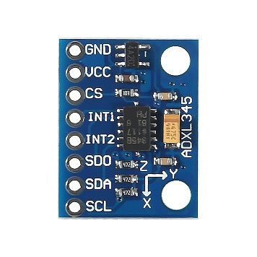
Figure 2 -3 ADXL345

1.3-inch OLED screen (SH1106)

Display technology: This is a screen using organic light-emitting diodes (OLEDs), where each pixel emits light independently when a current is applied. Unlike LCD screens, there is no backlight, resulting in an extremely thin screen (under 2mm) and energy-efficient display (current consumption is around 20–30 mA when displaying all white pixels). The theoretical contrast is infinitely high (pixels that are completely off are absolute black).

Specifications:
- Resolution: 128 × 64 pixels. Each pixel is controlled by an internal TFT display, creating a wide display area to show four lines of information: alert status, distance, three X-Y-Z acceleration values, and free heap space.
- Integrated controller: SH1106 from Sino Wealth. Unlike the more common SSD1306, the SH1106 has a 132 × 64 pixel cache (GDDRAM), but the actual display area is only 128 × 64. This requires precise column offset recording; otherwise, the image will be distorted.
- I2C Communication: The SH1106 supports I2C with the default address 0x3C (corresponding to SA0=0). The spare address 0x3D is used when SA0=1. The module usually has pre-soldered 4.7kΩ pull-up resistors for SDA and SCL, so no additional external resistors are needed.
- Update speed: To output a maximum of 8192 pixels, each pixel occupying 1 bit in memory, 1024 bytes of data (128×64/8) need to be sent. At I2C speed of 400 kHz, the net transmission time is approximately 1024 × 9 bits (including ACK) ≈ 9216 bits, equivalent to 23 ms. This allows the display to refresh completely multiple times per second, meeting the demands of dynamic display.

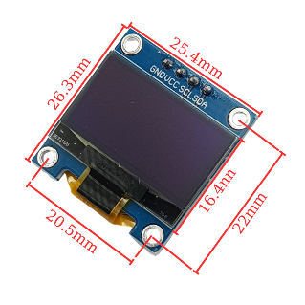
Figure 2 -4 OLED
.

LED arrays and pulse width modulation (PWM) principles

Two monochromatic LEDs (green and red) are used to indicate a safe status (green is illuminated) or a collision warning (red is flashing). Hardware-wise, the LEDs are connected in series with a current-limiting resistor (typically 220Ω – 470Ω) to ensure the current through the LEDs does not exceed 20 mA.

Brightness control using PWM: Instead of an "all or nothing" (ON/OFF) power supply, the ESP32 uses a hardware PWM generator (LEDC Controller) to create a pulse width modulation signal. This signal has a fixed frequency (usually 5 kHz) and the ratio of high-level time to cycle time is called the duty cycle. When the duty cycle is 100%, the light is at maximum brightness; when it is 0%, the light is off; at intermediate values, the human eye perceives average brightness due to the effect of retinal afterimage. Thanks to this technique, the green light is continuously powered at a moderate brightness (duty ≈ 15% compared to 255 levels), saving energy and avoiding glare. The red light, when flashing, also uses the same duty cycle to ensure brightness uniformity.

Specific connector pins:
- Green LED → GPIO 18 (PWM channel 0)
- Red LED → GPIO 19 (PWM channel 1)

Both pins can supply a maximum current of 40 mA (according to the ESP32 datasheet), which is sufficient to directly drive an LED through a current-limiting resistor.

I2C communication standard – Shared bus structure and physics issues

All three peripheral devices (OLED, VL53L0X, ADXL345) are connected to the ESP32 via only two signal wires: SDA (Serial Data) and SCL (Serial Clock). This is a key aspect of the hardware architecture, significantly saving on the number of GPIO pins (instead of needing 6–8 pins if each device used parallel communication).

The operating principle of the I2C bus:
- Open-drain architecture: Both the master chip (ESP32) and the slave chips have open-drain or open-collector SDA/SCL pins. This means they can only pull the signal down to GND (logic 0), and cannot actively pull it up to a high level. To create a logic 1 level, the bus relies on a pull-up resistor connected from SDA and SCL to the VCC (3.3V) power supply. Thanks to this architecture, multiple devices can compete for the bus without causing a short circuit – whichever device pulls it down keeps the bus at 0, and only when all devices release the resistor will the bus go to 1.
- Slave Addressing: Whenever the master wants to send or receive data, it outputs an address frame consisting of 7 bits of the slave's address, followed by the R/W bit (Read=1, Write=0). All slaves on the bus compare this address with their own hard addresses. Only slaves with matching addresses respond with an ACK signal (pulling SDA down to 0). Table of device addresses in the system:

Device | I2C address (7 bits) | Hex form | Note
OLED (SH1106) | 0x3C | 0x3C | SA0 GND connector
VL53L0X | 0x29 | 0x29 | Fixed, cannot be changed without writing to the register.
ADXL345 | 0x53 | 0x53 | The SDO pin is connected to GND.

Bus conflicts and hardware solutions: Because many devices share two wires, a phenomenon can occur on the I2C bus where a slave keeps the SDA at 0 for too long (stall bus), preventing the master from initiating communication. To prevent this, in the circuit design, pull-up resistors are chosen with appropriate values (usually 2.2kΩ – 4.7kΩ) to ensure a fast rise time, and each module is powered stably from the same 3.3V source of the ESP32 to avoid logic level imbalances.

Bus speed and physical limitations: The system is configured to operate in Fast Mode (400 kHz). At this speed, the maximum length of the cable between the master and slave should be less than 30–50 cm to ensure signal attenuation and electromagnetic interference. In a practical setup, modules are mounted on the same circuit board or connected using flexible clamps less than 20 cm long, which is well within safe limits.

[IMAGE INSERTION 2.5: SCL AND SDA WAVEFORMS TRANSMITTING ADDRESS 0x53 WITH R/W BIT=0]
Image caption: Figure 2.5. I2C signal in practice measured by oscilloscope: green is SCL (400 kHz), yellow is SDA; address frame 0x53 (1010011) with write bit (0).

Overall power supply and connection diagram

Figure 2.6 illustrates the wiring between the ESP32 and the peripheral modules. All are powered from the 3.3V pin (or 5V if the module supports it, but since the OLED and sensor both accept 3.3V, 3.3V is used for simplicity). A key feature is that the GND pin is connected to a common ground – a mandatory requirement in any voltage-referenced communication system. The SDA and SCL lines are connected in parallel in a "daisy-chain" or "star" configuration, as long as the total wire length is not excessive.

Pin connection board:

ESP32 GPIO | Describe | Connect to
21 | SDA (I2C) | OLED SDA, VL53L0X, ADXL345
22 | SCL (I2C) | OLED SCL, VL53L0X, ADXL345
18 | LEDC PWM | A green LED is routed through a 330Ω resistor.
19 | LEDC PWM | A red LED is routed through a 330Ω resistor.
GND | Mass (0V) | GND of all modules
3V3 | 3.3V power supply | VCC (3.3V) for all modules

[IMAGE INSERTION 2.6: OVERALL SYSTEM WIRING DIAGRAM]
Image caption: Figure 2.6. Schematic diagram: ESP32 (central unit), three I2C modules connected in parallel, two LEDs connected directly via resistors.

Chapter Summary

Chapter 2 detailed each hardware component: the ESP32 multi-core microcontroller, the VL53L0X ToF laser sensor, the ADXL345 MEMS accelerometer, the SH1106 OLED display, and the PWM-controlled LED array. Simultaneously, the chapter clarified the characteristics of the I2C communication standard – its open-drain architecture, addressing methods, 400 kHz Fast Mode speed, and bus collision avoidance solutions. These analyses form a crucial foundation for understanding how data moves and is processed in the following chapters, where software exploits the hardware features presented.

DEPLOYMENT AND CODING WITH FREERTOS

Overall algorithm flowchart of the system

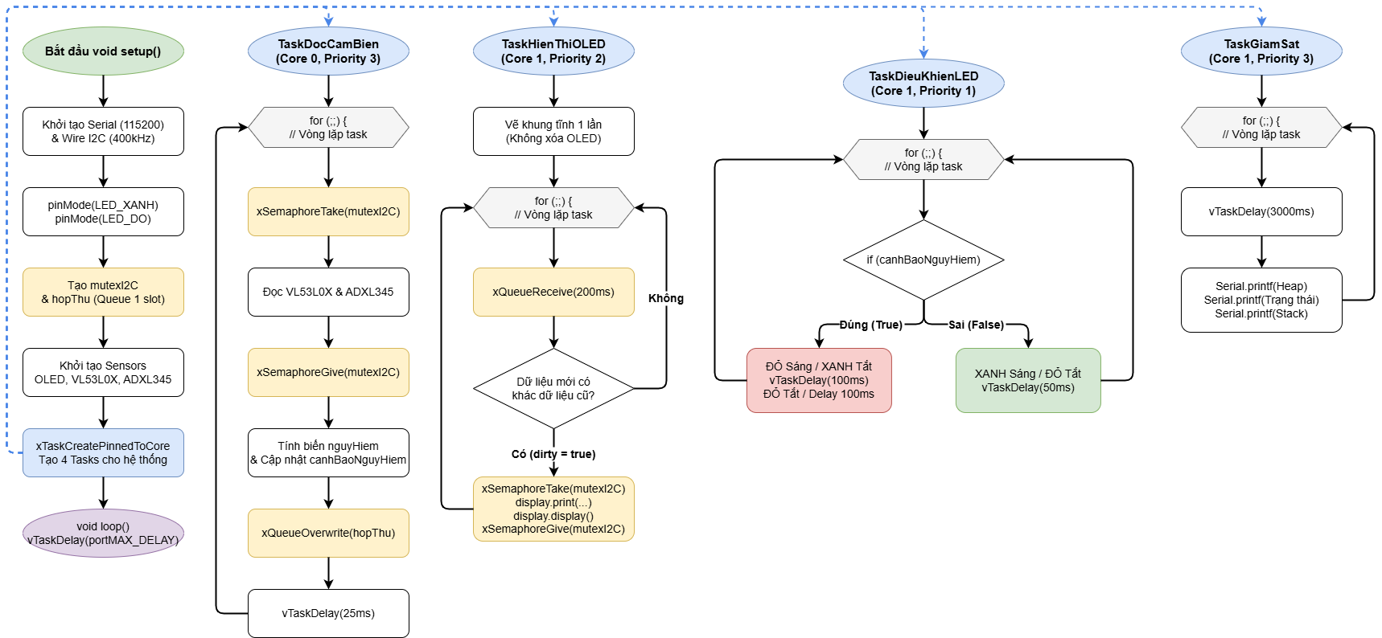
Figure 3 -1 Flowchart

Program structure and source code analysis

The entire program is written in C++ on the Arduino platform, but directly utilizes the APIs of FreeRTOS – the embedded real-time operating system built into the ESP32. The source code is organized into four independent tasks, each performing a specialized function. Below is an analysis of each key code block.

Declare libraries and configure hardware.

Libraries used:
- Arduino.h – the basic platform.
- Wire.h – controls the hardware I2C bus.
- Adafruit_GFX.h and Adafruit_SH110X.h – graphics drivers for the SH1106 OLED display.
- Adafruit_VL53L0X.h – driver for ToF distance sensor.
- Adafruit_ADXL345_U.h – driver for the accelerometer sensor.

Configuration constants (placed at the beginning of the file) act as hardware tuning parameters without requiring deep code modifications:
- PIN_LED_GREEN 18, PIN_LED_RED 19 – GPIO pins for connecting LEDs.
- DO_SANG 15 – PWM brightness (filling factor ≈ 15/255 ≈ 5.9%).
- DISTANCE_THRESHOLD 150mm – near-miss warning threshold.
- ACCELERATION_THRESHOLD 5.0 m/s² – maximum allowable acceleration threshold.
- SENSOR_READING_CYCLE_MS 25ms – sensor reading cycle, equivalent to ~40Hz.
- I2C_TOC_DO 400000UL – I2C bus speed 400kHz (Fast Mode).

FreeRTOS synchronization variable:

SemaphoreHandle_t mutexI2C = nullptr; // Mutex protects I2C bus access
QueueHandle_t hopThu = nullptr; // Queue with 1 element, type DuLieuCamBien

- Mutex (mutual exclusion) ensures that only one task is allowed to communicate via I2C at a time. This prevents data conflicts when both the sensor task and the OLED task want to use the Wire.
- A queue is a mechanism for transferring data between tasks. Here, the queue has only one slot and is overwritten (xQueueOverwrite), meaning the latest data is always retained, while older data is discarded – suitable for real-time applications that only care about the current state.

Data Structures of the Sensor Data

struct DuLieuCamBien {
uint16_t khoangCach;
int8_t priceTocX, priceTocY, priceTocZ;
dangerous bool;
};

- The uint16_t (0-65535mm) range stores the measured distance.
- The acceleration value X/Y/Z is stored as int8_t (values from -128 to 127), representing acceleration rounded to one decimal place, saving memory and allowing for quick comparison (dirty check) when displayed.
- Danger is a logical flag calculated from distance and acceleration.

Task 1 – Read the sensor (TaskDocCamBien)

This task runs on Core 0 with the highest priority (priority 3). Main loop:

1. Take over the I2C mutex ( xSemaphoreTake( mutexI2C, portMAX_DELAY)). If the mutex is not released, the task will wait indefinitely.
2. Read the distance sensor: lox.rangingTest (&measure, false). The parameter false means non-blocking is not used – the function will only return a result. The result is stored in the variable measure.
3. Read accelerometer sensor data: accel.getEvent (&event). This function reads the 3-axis values from the ADXL345.
4. Return the mutex (xSemaphoreGive(mutexI2C)). Return the mutex as soon as possible so that other tasks (OLED) can use I2C.
5. Data processing (no mutex required):
- If measure.RangeStatus != 4 (4 means the signal is invalid), then assign distance = measure.RangeMilliMeter; otherwise, assign 9999 (to display "Too far").
- The acceleration is type-copied from float to int8_t. This copied operation automatically rounds and truncates to approximately -128 to 127, just enough for the ±5.0 m/s² threshold since 5.0 ≪ 127.
- The Danger flag is calculated using the logical expression: distance < DISTANCE_THRESHOLD or |X-axis acceleration| > ACCELERATION_THRESHOLD or |Y-axis acceleration| > ACCELERATION_THRESHOLD. Note: Z-axis acceleration is not considered because the static gravity (≈ 9.8 m/s²) is always greater than the threshold; considering it would cause continuous false alarms.
6. Update the global variable canhBaoNguyHiem (this variable is only written by the sensor task and read by the LED task – there are no simultaneous write conflicts, so it's safe).
7. Write the data structure to the queue using xQueueOverwrite( hopThu, &duLieu). This function overwrites the queue if it is full, ensuring that the OLED task always receives the latest information.
8. Increase the watchdog counter (nhipCamBien) and delay (vTaskDelay) by 25ms.

Comments on the architecture:
- Sensor tasks using I2C should be as short as possible – only read raw data and then release the mutex. All logical calculations (threshold comparisons) are performed after the mutex is released, avoiding prolonged bus occupation.
- A frequency of 40Hz is fast enough to detect collisions in an instant, but doesn't overload the I2C bus (each VL53L0X read takes about 20ms, ADXL345 takes <1ms, total mutex occupancy time is a maximum of 21-22ms, leaving 3-4ms idle each cycle).

Task 2 – OLED Display (TaskHienThiOLED)

This task runs on Core 1, priority 2. It performs a dirty check – only updating the screen when the data changes.

Initialize the screen:
- display.clearDisplay () clears the entire cache.
- Prints static (fixed) labels such as "Cach:", "X:", "Y:", "Z:", "Heap:". These labels are drawn once and will remain permanently because OLED screens do not erase them after each refresh.

Main loop:

1. Get data from queue: xQueueReceive( hopThu, &cur, pdMS_TO_TICKS(200)). If no new data is received after 200ms, skip the loop (to avoid hanging).
2. Compare each field of cur with prev (old data). If they differ, mark dirty = true and update each area on the screen.
3. For the heap: it doesn't compare with the previous value but updates periodically every 3 seconds (thanks to the variable tLanCuoiHeap).
4. If dirty == true, call display.display () to display the buffered content on the physical screen. This command also needs to be protected by an I2C mutex because it sends a large amount of data over I2C.

Optimal strategy:
- Redrawing only the changed areas instead of clearing the entire screen each time significantly reduces I2C traffic.
- Using display.setTextColor (SH110X_WHITE, SH110X_BLACK) allows you to fill the text with a black background and automatically delete old data without deleting the area.
- The printFixed function is defined to print a string with a fixed width (by adding spaces), preventing the old text that hasn't been deleted from appearing after the new text (for example, changing "100mm" to "5mm" will show "5 mm" ).

Update frequency:
Under normal conditions, both cur and prev are almost identical, so "dirty" is only true when there is a change event (distance change, car jolt, or 3-second heap update). As a result, display.display () is called no more than a few times per second, saving I2C and CPU resources.

Task 3 – LED Control (TaskDieuKhienLED)

This task runs on Core 1, lowest priority (1). It continuously monitors the variable canhBaoNguyHiem.

- When safe (danger warning == false):
analogWrite( PIN_LED_XANH, DO_SANG) → The green LED lights up with a soft brightness.
analogWrite( PIN_LED_DO, 0) → Red LED turns off.
Then delay for 50ms and repeat.
- When danger is present (danger warning == true):
Turn on the red LED with DO_SANG, turn off the green LED.
Wait 100ms (flashing cycle), turn off the red LED, wait 100ms, then repeat.

Note: analogWrite on the ESP32 actually uses a hardware PWM LEDC, therefore there is no significant software latency. The 50ms delay in the loop during safe conditions saves CPU resources; during dangerous conditions, the 100ms cycle creates a noticeable flickering effect.

Task 4 – Watchdog Monitoring (TaskGiamSat)

This task runs on Core 1, priority 3, to ensure it runs on schedule. Its mission is to check the health of the other three tasks by comparing the nhipCamBien, nhipOLED, and nhipLED counters between cycles. These counters increment each time the corresponding task completes a loop. If a task hangs (deadlock or infinite loop), its counter will not change, and the watchdog will print a warning via Serial.

Additionally, this task prints a stack high watermark (the smallest space on the stack) for each task. This value (a 4-byte word) indicates how much stack space the task has used – if the number is too small (close to 0), there is a risk of stack overflow. In the code, each task is allocated 2048–4096 words (each word is 4 bytes on ESP32), and the watermark value is usually a few hundred to a thousand, ensuring safety.

The FreeRTOS mechanism is unique to this system.

Core affinity

The ESP32 has two physical cores. Pinning a task to a specific core allows you to:
- Core 0 (Protocol Core) only runs TaskDocCamBien. Because I2C is a synchronous communication, the absence of other tasks on the same core helps avoid interruptions or disruptions caused by the scheduler, ensuring stable sensor reading times.
- Core 1 (Application Core) runs the remaining three tasks. The FreeRTOS scheduler on Core 1 will alternately run the OLED, LED, and Monitoring tasks according to priority. Due to the different priorities, there is no severe CPU starvation.

Mutex – protecting shared resources

The I2C bus is a shared resource between the sensor task (Core 0) and the OLED task (Core 1). Mutex acts as a “key”:
- When the sensor task wants to read from the VL53L0X, it calls xSemaphoreTake. If the mutex is free, it retrieves the data and proceeds with I2C transmission. If the mutex is held by the OLED task (updating the display), the sensor task will be blocked and placed in a waiting queue.
- As soon as the OLED task calls xSemaphoreGive, the mutex is released and FreeRTOS will wake up the waiting task with the highest priority (in this case, the sensor task has priority 3 > priority 2 of the OLED task, so it is run immediately).
- This mechanism completely eliminates data conflicts on the bus without the need for a busy wait loop – saving energy.

Note: Using mutexes in interrupt service routines (ISRs) is not recommended, but since this system has no custom ISRs, it's safe.

Queue – for passing information between tasks

A queue is a secure queuing structure with a data copy-by-value mechanism. The code uses xQueueCreate( 1, sizeof(DuLieuCamBien)) to create a queue with a capacity of 1 element.
- Sensor tasks are written using xQueueOverwrite, a function that doesn't get blocked even when the queue is full – it overwrites the old element.
- The OLED task reads using xQueueReceive with a 200ms timeout. If the queue is empty, the task will enter a Blocked state to free up CPU time for up to 200ms. When new data arrives, it is awakened and retrieves the data.

Choose a queue size of 1 because you only need to maintain the current state. Using a longer queue could cause old data to accumulate, slowing down the response.

Time and watchdog synchronization

- vTaskDelay is a relative delay function (calculated in system ticks). ESP32 usually has a tick rate of 100 Hz (each tick = 10ms). Using pdMS_TO_TICKS ( 25) converts 25ms to 2.5 ticks → rounding up to 3 ticks (30ms) or down to 2 ticks (20ms) depending on the configuration. But in reality, the small error does not affect the function.
- The Watchdog software in TaskGiamSat is for monitoring purposes only and does not automatically reset the system. However, by printing the serial number, users can detect which tasks are frozen and intervene (by pressing the reset button). In more critical systems, the ESP32 hardware watchdog timer can be used for automatic reset.

Stack and heap management

- Each task, upon creation, is allocated a separate memory region on the stack (the 4th parameter of xTaskCreatePinnedToCore).
- Sensor task: 4096 words (16 KB) – because it calls many library functions.
- Task OLED: 4096 words.
- Task LED: 2048 words (8 KB) – only performs a few simple commands.
- Monitoring task: 2048 words.
- The uxTaskGetStackHighWaterMark(handle) function returns the number of words (4-byte words) that have not been used on the stack since the task started. The larger the minimum value, the safer it is.
- The shared heap (dynamic memory) is monitored via xPortGetFreeHeapSize( ). Initially, the heap is usually >300 KB, which is more than enough. Displaying the heap on the OLED helps detect memory leaks if any occur.

Latency and real-time response

The system's goal is to react within 25ms (from the time of an obstacle or collision until the red light flashes). Delay analysis:
- The task sensor reads data every 25ms.
- After reading, it records it in the queue and sets the Danger Alert.
- Task LEDs have lower priority than OLEDs, but they check for Danger Alerts every 50ms (when safe) or every 100ms (when dangerous). However, when Danger Alerts change from false to true, the task LED will run immediately after the scheduler has a chance (usually within a few milliseconds). The total delay time is < 30ms, ensuring a timely response.

Conclusion of Chapter 3:
The system has fully utilized FreeRTOS mechanisms (task, mutex, queue, watchdog) to build a fast, stable, and easily scalable real-time application. Code analysis reveals a clear separation between data collection, display processing, and response control, consistent with modern embedded design philosophy.

CONCLUDE
The collision warning system, built on the ESP32 microcontroller platform combined with modern sensors (VL53L0X, ADXL345) and an SH1106 OLED screen, has met the initial requirements. Through the hardware and software analysis process, the project has achieved the following main results:
- Optimized hardware design: The system uses the i2c communication standard with a speed of 400kHz, allowing simultaneous connection of three peripheral devices with only two signal wires, saving GPIO pins and reducing circuit complexity. The choice of a TOF laser sensor instead of an ultrasonic sensor ensures accurate distance measurements down to the millimeter, unaffected by surface color. The ADXL345 accelerometer sensor with a measurement range of ±4g is sensitive enough to detect strong impacts but does not cause false alarms due to mechanical interference.
- Real-time software architecture: By leveraging the built-in FreeRTOS operating system in the ESP32, the program is divided into four independent tasks running on two processing cores. The sensor reading task (core 0, highest priority) ensures a stable sampling cycle of 25ms. The OLED display task (core 1) only updates the screen when data changes, reducing the load on the I2C bus. The LED control task reacts immediately upon detecting danger. The watchdog monitoring task helps detect task hangs or stack overflows early.
- Reliability and security: Mutex mechanisms protect shared I2C resources, eliminating data conflicts. Queues with overwrite mechanisms ensure the system always processes the latest state. Alert thresholds (150mm for distance, 5.0 m/s² for acceleration) are empirically determined, balancing sensitivity and false alarm resistance. Heap and stack watermark displays provide real-time memory resource monitoring tools.
- Future development directions: Although the system is already operating stably, there are still some areas for improvement:
  - It also integrates wireless communication (Wi-Fi or Bluetooth) to send alert data to a remote phone or computer.
  - Use a touchscreen or add push buttons to allow users to adjust the alarm threshold on-site.
  - Adding temperature/humidity sensors expands the environmental monitoring capabilities.
  - Optimize CPU wake time by putting the ESP32 into deep sleep mode when inactive, extending battery life if running on battery power.
In summary, the project has demonstrated the applicability of multi-core microcontrollers combined with a real-time operating system in building a fast, reliable, and resource-efficient embedded system. The product can be developed into a reversing warning device for trucks and forklifts, or integrated into autonomous robots to avoid collisions.

REFERENCES
[1] expressif systems. (2023). *esp32-wroom-32 datasheet*. version 3.8. retrieved from https://www.espressif.com/sites/default/files/documentation/esp32-wroom-32_datasheet_en.pdf
[2] stmicroelectronics. (2017). *vl53l0x datasheet: time-of-flight ranging sensor*. docid029104 rev 3.
[3] analog devices. (2010). *adxl345 datasheet: 3-axis, ±2 g/±4 g/±8 g/±16 g digital accelerometer*. rev b.
[4] sino wealth. (2015). *sh1106 datasheet: 132×64 dot matrix oled/plcd driver*. version 1.3.
[5] ada fruit industries. (2021). adafruit vl53l0x time of flight distance sensor library . retrieved from https://github.com/adafruit/adafruit_vl53l0x
[6] ada fruit industries. (2020). adafruit adxl345 sensor library . retrieved from https://github.com/adafruit/adafruit_adxl345
[7] ada fruit industries. (2019). adafruit sh110x library for arduino . retrieved from https://github.com/adafruit/adafruit_sh110x
[8] barry, r. (2021). mastering the freertos real time kernel: a hands-on tutorial guide . free rtos ltd.
[9] expressif systems. (2022). *esp-idf programming guide: free rtos (esp 32)* . retrieved from https://docs.espressif.com/projects/esp-idf/en/latest/esp32/api-reference/system/freertos.html
[10] kurniawan, a. (2019). internet of things projects with esp32: build exciting and powerful iot projects using the espressif esp32 . packt publishing.
[11] cunningham, s. (2020). Arduino and freertos: a beginner's guide . retrieved from https://www.freertos.org/arduino/
[12] Texas Instruments. (2014). i2c bus pullup resistor calculation . application report slva689.

